**Самченко Станислав** *ІТІНФ-20-1* вариант - 21



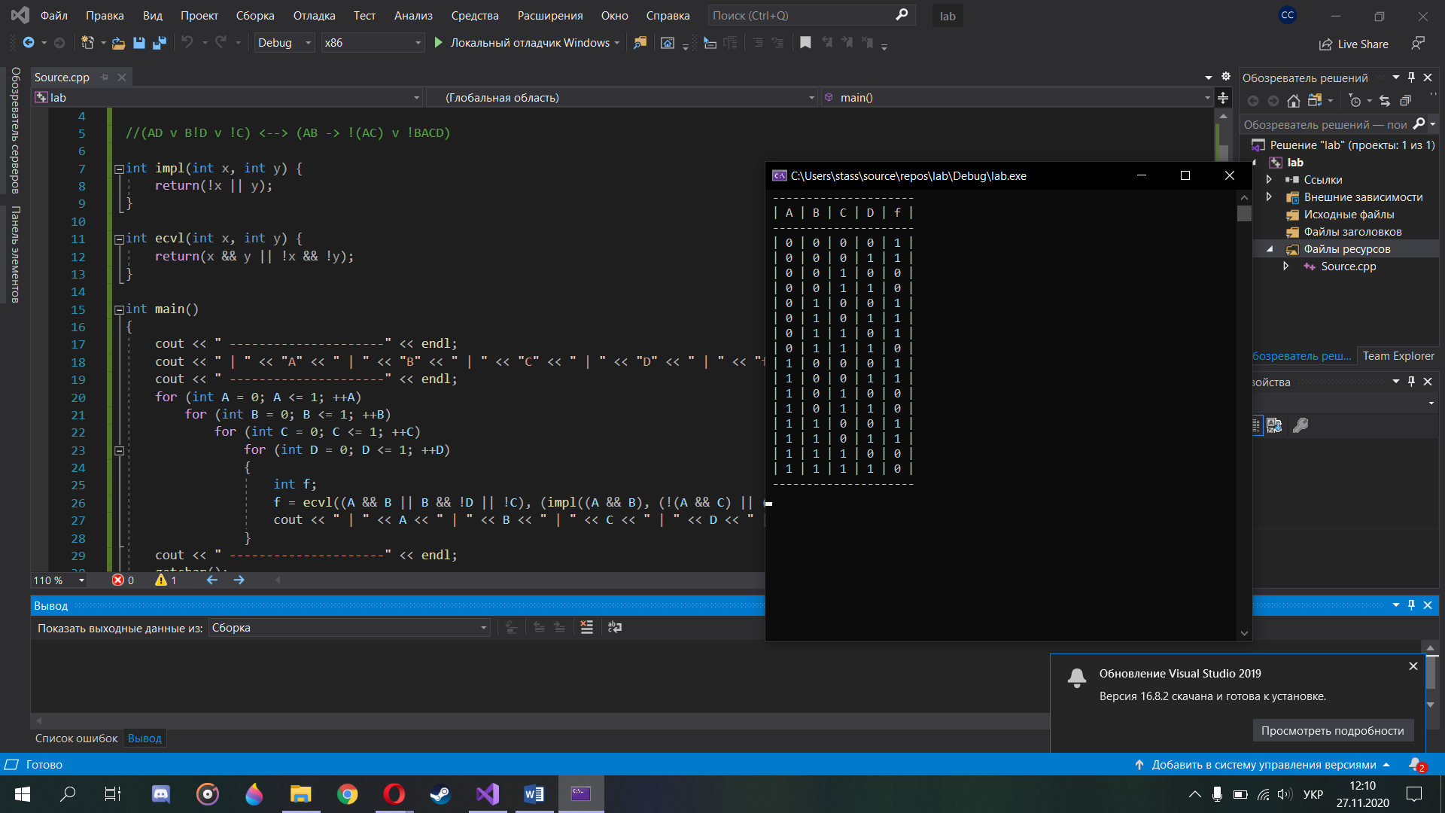

#include <iostream>

#include <stdlib.h>

using namespace std;

//(AD v B!D v !C) <--> (AB -> !(AC) v !BACD)

int impl(int x, int y) {

return(!x || y);

}

int ecvl(int x, int y) {

return(x && y || !x && !y);

}

int main()

{

cout << " ---------------------" << endl;

cout << " | " << "A" << " | " << "B" << " | " << "C" << " | " << "D" << " | " << "f" << " | " << endl;

cout << " ---------------------" << endl;

for (int A = 0; A <= 1; ++A)

for (int B = 0; B <= 1; ++B)

for (int C = 0; C <= 1; ++C)

for (int D = 0; D <= 1; ++D)

{

int f;

f = ecvl((A && B || B && !D || !C), (impl((A && B), (!(A && C) || (!B && A && C && D)))));

cout << " | " << A << " | " << B << " | " << C << " | " << D << " | " << f << " | " << endl;

}

cout << " ---------------------" << endl;

getchar();

return 0;

}